User Stories for analyzing Copy Number

Phase 2 caDNACopy Output

- Summary: User wants to get a list of patients/samples that have a copy number alteration greater than X at any point over an interval on the genome, where the interval is specified by the user.
Details: As a study investigator, user wants to create a query based on copy number values as determined by the caDNACopy (using CBS) algorithm. The user initiates a new query. On the Criteria tab, the user selects “Copy Number” and clicks the add button. User sees a new criterion row labeled “Copy Number”. Within the row, the user selects
- Upper limit of the copy number alteration - User enters X and selects “>” or “<”.
- Lower limit of the copy number alteration [optional] - User enters X and selects “>” or “<”.

In the same row, the user also selects from a dropdown for the genome interval and can choose ONE of the following:
- Gene Name(s) – [default] Selecting this reveals the current “Gene Picker” and regions covered by these genes will be queried.
- Chromosome Coordinates – Selecting this reveals 2 text boxes for entering 2 numeric coordinates. Region between the coordinates will be queried.
- Chromosome Number – Selecting this reveals 1 text box for entering 1 thru 24. Region within the entire chromosome will be queried. It also will reveal the Chromosome Number box, and the user will have to enter a chromosome that the coordinates belong to.

Screenshot of Copy Number criterion for Gene Name:
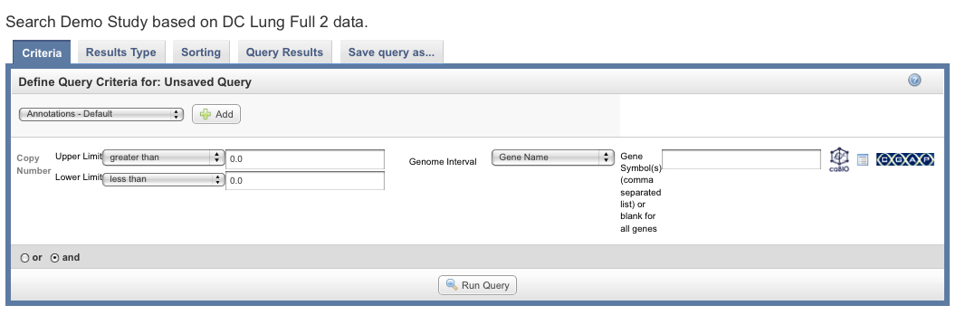

Screenshot of Copy Number criterion for Chromosomal Coordinates:

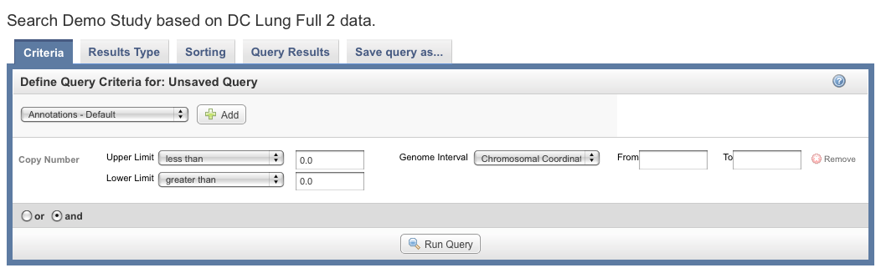

On the Results Type tab, the user sees an additional option for “Copy Number” and selects it. User clicks “Run Query”. The Query Results tab shows a data matrix containing samples vs. genomic region. Parallel to genomic region are Gene Symbols. The values in the table cells are the mean segment value as reported by caDNACopy.

++++++

